churchweek

Weekly Notices
August 30th - The Rev. Ruth Monette will preside over the 8am and 10am services

There will be a memorial service to celebrate the life of Eva Mary Boddington on Saturday, August 29th in the St. Catherine’s Sanctuary. The service begins at 11:00am and will be followed by a reception in the Mary Pellat Room.

Patricia Mary McCance passed away on August 25th. Once funeral arrangements have been finalised a notice will be sent to the St. Catherine’s community

Unsung Volunteers!

So many people volunteer for jobs around St. Catherine’s Church it would be difficult to name them all. However, here are a few of those who work ‘behind the scenes’.

Thank you to Elizabeth Lee who has served the last four years as our envelope secretary. This volunteer job has included counting the “Offering” each week, keeping a record of all donations, and sending out Tax Receipts.

Thank you to those who each Sunday see that coffee, tea, and juice is available after Church. Thank you to Kirsty Milligan, who sees that the kitchen is clean each week. (Note: We are in need of more volunteers for this Ministry. It requires doing this about once every eight weeks. Talk to Kirsty if you would be interested.)

Thank you to Mary Savage, Phil Severy, and Steve Jackson who have worked diligently to keep the Memorial Garden looking very nice, even though the dry spell this summer and all within the watering regulations.

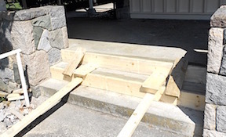
Thank you to Nairn Grundy who engineered getting a number of our good chairs welded so that they could, again, be used. Also, we have Nairn to thank for repairing our cement stairs on Ridgewood.

